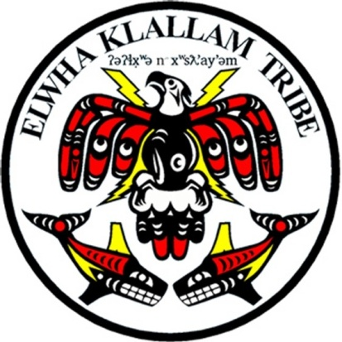
LOWER ELWHA KLALLAM TRIBE
Position Description
DENTIST

OVERVIEW: This position is to provide quality dental care and services to patients at the Tribe’s Lower Elwha Health Clinic. This position is covered by the Federal Tort Claims coverage and Professional Liability Insurance while providing dental services for the Tribe, as long as the dentist is performing services as outlined in the job description.

LOCATION: Lower Elwha Health Department
SUPERVISED BY: Health and Human Services Director
POSITION STATUS: Full-time w/benefits
SALARY LEVEL:
WORK SCHEDULE: Hours to be determined by supervisor

ESSENTIAL FUNCTIONS OF JOB:
- Provide direct patient dental services, including diagnosis, treatment and referral when appropriate based on the policy and procedures of Contract Health Services.
- Perform the full scope of dentistry: common and complicated operative, root canals, dentures, partials, comprehensive exams, crown, extractions and bridges.
- Obtain and interpret diagnostic tests (including CBCT) as needed.
- Provide support and direction to clinical support team.
- Shall be an active participant in continuing quality improvement processes.
- Participate and cooperate as needed with the activities of the Health and Human Services Administration and attend meetings regarding patient care management.
- Respond to telephone calls from Olympic Medical Center hospital staff, nursing home staff, Dentists, Pharmacies, Patients, and others as needed.
- Shall keep and maintain appropriate records using the SOAP for all professional services rendered by him/her in a timely manner.
- Ability to treat all patients with respect and compassion, giving quality care.
- Ability to treat all staff with respect and compassion.
- Supervision: All duties will be performed under the direction of the LEHD Dental Director and Health Director.

MINIMUM QUALIFICATIONS:
- Must have a valid dental degree from a certified dental school and be licensed to practice dentistry by the State of Washington.
- Must maintain current Washington State Dental license while employed.
- Must be able to maintain and improve professional skills as required for licensure, and the safe and quality practice of dentistry.
- Must be able to furnish all known insurance provider numbers, including Washington State Medicaid identification numbers.
- Must become and maintain a current status as a PPO with those insurance companies that the Tribe, in its sole discretion, deems necessary.
- Must have and maintain an automobile and personal telephone at their own expense.
- Shall secure any licenses and professional dues at their own expense.

- Must furnish a current copy of the following prior to initial hire, and upon subsequent request of the Tribe:
- DEA license
- Dental license
- Proof of any applicable Board Certifications; and
- Curriculum vitae to be used to obtain PPO status with Tribal designated insurance companies.

PHYSICAL REQUIREMENTS:
- Walking and standing; sitting down for long period of time
- Able to lift and carry light loads approximately 25 pounds
- Requires use of standard office equipment, including computer, phone, fax, and photocopier, dental equipment
- Need to be able to effectively deal with a diverse, public population; being tactful and friendly

OTHER DUTIES AND REQUIREMENTS:
- Must be able to comply with the LOWER KLALLAM TRIBE policies and procedures, including the Drug Free Workplace
- Demonstrated knowledge and the ability to model the expectations of confidentiality.
- The dentist shall comply at all times, with all reasonable requests of the Tribe.
- The dentist shall not take any individual dental records outside the physical premises of the Clinic, except when they are being used for staffing purposes within other Tribal facilities.
- The dentist shall submit to a physical examination by three Doctors whenever the Tribe considers it necessary to properly evaluate the physical or mental capability of the dentist to fulfill the terms of this Agreement.
- Confidentiality: The dentist agrees that during the term of employment or at any time after termination, any and all knowledge or information that may be obtained during the course of employment with respect to the conduct and details of all Tribal business will be forever held inviolate and be concealed from all other persons except upon application for a proper purpose and subject to prior written authorization of the Tribe, which authorization it may withhold in its sole discretion; and in respect to patient confidential medical information will be forever held inviolate and be concealed from all other persons except upon application for a proper purpose and subject to the prior written authorization of the Patient.
- The dentist shall submit to a criminal background check.

With all positions of the Lower Elwha Klallam Tribe this position is Indian Preference in hiring, in accordance with P.L. 93-638.

OPENING DATE:
CLOSING DATE:
CONTACT:

